

OUTDOOR EDUCATION STAGE 2 SAMPLE EXAMINATION

Section 7 of the New WACE Manual: General Information 2006–2009 outlines the policy on WACE examinations.

Further information about the WACE Examinations policy can be accessed from the Curriculum Council website at http://newwace.curriculum.wa.edu.au/pages/about_wace_manual.asp.

The purpose for providing a sample examination is to provide teachers with an example of how the course will be examined. Further finetuning will be made to this sample in 2007 by the examination panel following consultation with teachers, measurement specialists and advice from the Assessment, Review and Moderation (ARM) panel.

0000.doc




Western Australian Certificate of Education, Sample External Examination
Question/Answer Booklet

OUTDOOR
Please place your student identification label in this box
EDUCATION
WRITTEN PAPER
STAGE 2

Student Number: In figures

In words

Time allowed for this paper
Reading/planning time before commencing work: Ten minutes
Working time for paper: Three hours

Material required/recommended for this paper

To be provided by the supervisor
Question/Answer Booklet
Multiple Choice Answer Sheet

To be provided by the candidate
Standard items: Pens, pencil (for multiple choice section), eraser or correction fluid, highlighter, ruler, printed English language dictionary and/or bilingual dictionary (not electronic and not a thesaurus)

Special items: Compass

Important note to candidates
No other items may be taken into the examination room. It is your responsibility to ensure that you do not have any unauthorised notes or other items of a non-personal nature in the examination room. If you have any unauthorised material with you, hand it to the supervisor before reading any further.

Structure of this paper

Section | Suggested working time | Number of questions available | Number of questions to be attempted | Marks available | %
Section One:  Multiple Choice | 30 minutes | 20 | 20 | 20 | 10%
Section Two:  Short Response | 60 minutes | 10 | 10 | 60 | 45%
Section Three:  Extended Response | 90 minutes | 3 | 3 | 60 | 45%
 |  |  | [Total marks] | 140 | 100%

Instructions to candidates

- The rules for the conduct of Curriculum Council examinations are detailed in the Student Information Handbook. Sitting this examination implies that you agree to abide by these rules.

- For Section One you are provided with a Multiple Choice Answer Sheet. Use a pencil for all entries on this sheet. For each question, shade the box which indicates your answer.

- For Sections Two and Three, write your answers in the spaces provided in this Question/Answer Booklet. A blue or black ballpoint or ink pen should be used. Wherever appropriate, fully labelled diagrams, tables and examples should be used to illustrate and support your answers.

- You must be careful to confine your responses to the specific questions asked and to follow any instructions that are specific to a particular question.

- Spare answer pages may be found at the end of this booklet. If you need to use them, indicate in the original answer space where the answer is continued (i.e. give the page number).

SECTION ONE—Multiple Choice

A multiple choice answer sheet is provided for you to answer questions in this section. Use a pencil for all entries. For each question, shade the box which indicates your answer.

This section has TWENTY (20) questions. Attempt ALL questions.

Allow approximately 30 minutes for this section [20 marks].

- During the planning process for an expedition, which of the following factors should an individual consider?
[1 mark]
- goals, equipment, weather, access to location and duration
- equipment, terrain and water availability
- distance between campsites, vegetation and forecast
- all of the above.

- A satellite phone should be included on a leader’s equipment list as part of an emergency response plan for a school expedition because
[1 mark]
- it is seen to be best practice, using available technology
- it is detailed in the ‘Guidelines for Outdoor Education and Recreation Activities’
- students may need to call home
- it is recognised as an effective method of making contact with people.

- Which of the following methods would be the best method to evaluate the success of an outdoor experience in achieving its goals?
[1 mark]
- group reflection through a facilitated debrief
- personal reflection at the end of each day
- entries in a personal journal
- one-to-one interview

- The recommended process for initial response to an emergency is
[1 mark]
- assess for danger, assess the level of consciousness of the patient, and attend to life threatening conditions, stabilise the patient
- assess for danger, assess the situation, identify the number of patients and prioritise their care, attend to life threatening conditions, stabilise the patient
- assess the level of consciousness of the patient, apply appropriate first aid, monitor
- run as quickly as you can to get help.

- It is important to minimise our impact on the environment during outdoor experiences. The leave no trace principles address the different ways human impact can be minimised. Choose the answer below that contains all these principles.
[1 mark]
- travel and camp on durable surfaces, dispose of waste properly, cook on a portable stove, respect wildlife, wear natural coloured clothing and do not enter private property
- remove all signs of your presence in the environment, dispose of waste properly, only light a small fire and wash in large rivers but not small waterways
- don’t touch plant or animals, take photographs and leave only footprints
- plan ahead and prepare, travel and camp on durable surfaces, dispose of waste properly, leave what you find, minimise campfire impacts, respect wildlife, and be considerate of your hosts and other visitors.

- Which of the following are essential features on a topographical map?
[1 mark]
- scale, key, gridlines,
- year of publication, magnetic variations
- true north, scale, names of rivers
- name, title, date of publish

Use the synoptic chart below to answer the following two questions.
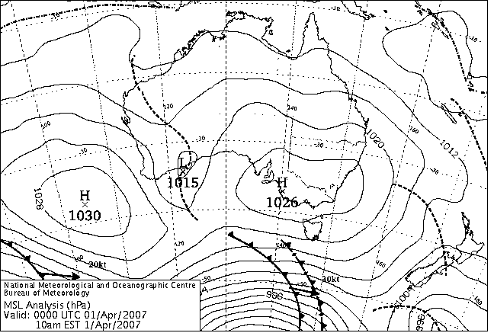

Perth

- Choose the best description for the likely weather Perth would be experiencing (wind, temperature, clouds, rain) on that day.
[1 mark]
- calm, approximately. 30°, stratocumulus clouds, no rain
- weak wind, approximately 20°, cumulus clouds, some rain
- calm, approximately 25°, scattered cumulus clouds, no rain
- strong winds, approximately 15°, cumulonimbus clouds, thunderstorms

- From the same map, what is the approximate barometric pressure reading for Perth and indicate whether it is likely to rise or fall?
[1 mark]
- 1015mmhg and rising
- 1023mmhg and rising
- 1025mmhg and falling
- 1030mmhg and rising
- What are the key elements in maintaining and caring for ropes?
[1 mark]
- keep out of direct sunlight, chemicals, correct storage, knot removal
- washing twice a year
- keeping in bag
- ensure ropes are frequently used

- The autocratic leadership style can best be described as
[1 mark]
- an approach in which the leader has complete power
- an approach which involves shared decision-making
- an approach in which the leader has given all power to the group
- an approach in which a leader is voted by the rest of the group.

- During a debrief participants are expected to
[1 mark]
- listen attentively and contribute honest thoughts and feeling to the group
- sit in a way that everyone else is clearly in view
- reflect on their experience
- all of the above.

- When selecting equipment for an expedition you need to consider
[1 mark]
- size and weight
- durability
- mode of transport
- all of the above.

- Which of the following is not describing ‘commitment’?
[1 mark]
- being dependable, trustworthy and putting everything into your work
- the willingness to commit an obligation to your goals and presenting towards these goals
- possessing a determination to achieve success
- underestimating the effort required to complete a task

- Humans are sensitive to levels of light. Which of the following factors would assist in getting a good night sleep when on a camping expedition?
[1 mark]
- sitting around a big campfire
- going to bed before sunset
- minimising artificial light around the campsite
- turning the lights off at the switch

- What does the abbreviation E.P.I.R.B. mean?
[1 mark]
- emergency position indicating radio beacon
- electronic position indicating radio beacon
- environmental position in a research blog
- external pipeline in red bedrock

- What combination of equipment would be most appropriate to take as essential items on a day excursion?
[1 mark]
- map, compass, whistle, first aid kit, torch, water
- map, compass, whistle, torch, water, shelter
- torch, water, first aid kit, food
- torch, water, first aid kit, mobile phone

- Effective leadership skills can be based on which combination of the following factors?
- knowledge of terrain
- knowledge of appropriate skills for the activity
- social status
- knowledge of participants
[1 mark]
Select the combination of skills below
- i, ii, iii
- i, ii, iv
- ii, iii, iv
- i, iii, iv.

- The stages of group development are
[1 mark]
- forming, norming, storming, adjourning
- forming, storming, norming, performing, adjourning
- forming, performing, norming adjourning
- norming, forming, performing, storming, adjourning.

- What information should always be included on an expedition route card?
[1 mark]
- start and finish points, distance, bearings, time taken to travel
- start and finish points, distance, bearings, key navigation points
- distance, escape route, hair colour, timing
- distance, escape route, bearings, time of sunset

- The presence of which cloud type in the sky would indicate the approach of a cold front in the next 24 hours?
[1 mark]
- cirrus
- cumulonimbus
- cumulus
- stratus

END OF SECTION ONE
SECTION TWO—Short response

This section has TEN (10) questions. Attempt ALL questions.

Allow approximately 60 minutes for this section [60 marks].

Question 1
Name and describe TWO (2) of each of the following skills of a good outdoor leader
- generic
- specific
- meta. [6 marks]

Question 2
The weather map below is to be used to help answer the following TWO (2) parts of this question.

Perth
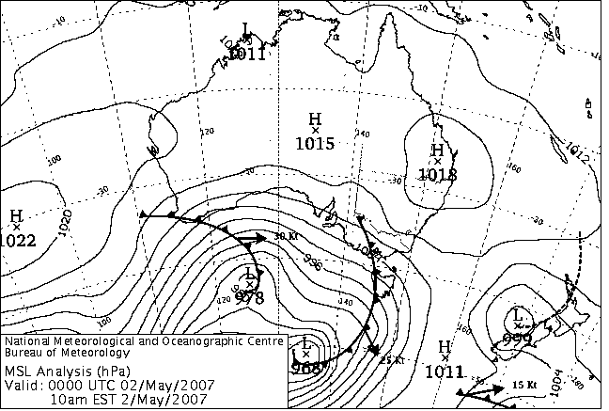

- Use the weather map above to write a forecast of the weather (approximate temperature, wind, rain, clouds) that Perth would be experiencing at the time this weather map was created.
[2 marks]

- Use the weather map above to detail a three day weather forecast (approximate temperature, wind, rain, clouds) for Perth. Enter this in the table below.
[4 marks]

 | Day 1 | Day 2 | Day 3
Temperature

Wind

Rain

Clouds

THIS SPACE HAS BEEN LEFT BLANK INTENTIONALLY

Question 3
The Johari Window (below) is a tool used to help people better understand their interpersonal communication skills and relationships with others.

Known to self
Known to others

Not known to self
Not known to others

Each of the four quadrants has a name. Write the correct name of each quadrant in the box provided in the diagram above and describe each quadrant in the space below.
[6 marks]

Question 4
The figure below shows a continuum of possible types of styles of outdoor leadership.

A B C D E F
Leader influence
True dictatorial
True laissez-faire
Follower Influence

[6 marks]
The letters A to F represent different styles of leadership. Use the information in the diagram to help you to identify each of the styles of leadership. Name and describe the style of leadership next to the letters below.

A __________________________________________________________________________
B ___________________________________________________________________________
C ___________________________________________________________________________
D __________________________________________________________________________
E __________________________________________________________________________
F __________________________________________________________________________

Question 5
Complete the table below.
[6 marks]
Picture of shelter | Name | Characteristics | Best suited to
For copyright reasons this image cannot be reproduced in the online version of this document, but may be viewed at http://www.mainpeak.com.au/product.aspx?productID=9700  [From: Mainpeak Australia, 2006] | Bivvy/hootchie
For copyright reasons this image cannot be reproduced in the online version of this document, but may be viewed at http://www.mainpeak.com.au/product.aspx?productID=13192  [From: Mainpeak Australia, 2006] | Three room tent
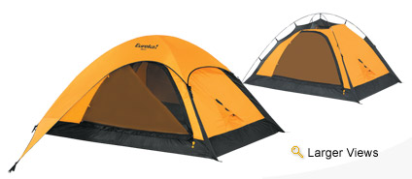  [From: Johnson Outdoors Inc., 2006] | Two season tent

Question 6
What is the purpose of a route card and what information is necessary to include on it?
[6 marks]

Question 7
Use the map below to complete the questions.
Magnetic variation is + 4º

x
B
x
A
N

- List the step-by-step procedure you would take to calculate a magnetic bearing from points A to B.
[3 marks]

- Use a compass to calculate the magnetic bearing from point A to point B.
[1 mark]
____________________________

- Use a compass to calculate the back bearing between point A and point B.
[1 mark]
____________________________

- What purpose does a back bearing serve?
[1 mark]

Question 8
It is important to be familiar with modern technology that could be used to assist in an emergency.

- Explain what an E.P.I.R.B is and how it works.
[3 marks]

- Explain what situations an E.P.I.R.B. is recommended to be used in.
[3 marks]

Question 9
You are the leader of a group of ten 15-year-olds on a five day bushwalking expedition. It is the afternoon of the second day. It has been raining steadily most of the day. The group stops for lunch under the shelter of some large trees. You notice that the group’s morale is quite low and two members of the group are sitting quietly on their own away from the group. They are slow to pack up at the end of lunch. After about 20 minutes walk, one of the two stumbles and falls.

Discuss the possible situation you are faced with in this scenario. Describe the actions you would take to manage the situation.
[6 marks]

Question 10
There are a number of natural environments within Western Australia that have parts determined to be at risk. Select one of the parts. Describe why it is at risk and the strategies that are being used to manage this environment. [6 marks]

END OF SECTION TWO
SECTION THREE—EXTENDED RESPONSE

This section has THREE (3) questions. Attempt ALL questions.

Allow approximately 60 minutes for this section [60 marks].

Question 11
It is important to minimise our impact on the environment while in the outdoors.

(a) Clearly outline the seven (7) leave no trace principles.
(b) Discuss how you applied these principles to one of the expeditions you were involved in this year and describe the minimum impact practices that you developed for this expedition.

[20 marks]

Question 12
Expedition equipment choices are vital in order to maximise personal comfort.

(a) Describe the factors you would consider when choosing equipment for an expedition.
(b) Discuss how these factors affected your choice of equipment for an expedition that you
attended this year.
[20 marks]

Question 13
According to Tuckman’s group theory, groups take time to develop.

(a) Name the stages that groups normally progress through as they develop.
(b) Describe the characteristics of the groups at each of these stages.
(c) Describe how your expedition group moved through these stages by giving an example of
actions or events typical of each stage. If your group did not move through these stages,
suggest reasons why.
[20 marks]

ACKNOWLEDGEMENTS

SECTION ONE

Questions 7–8: Chart from: Bureau of Meteorology. (2007). Weather charts—national and international (Latest mean sea level pressure chart: black & white). Retrieved April 1, 2007, from http://www.bom.gov.au/weather/national/charts/.

SECTION TWO

Question 2: Chart from: Bureau of Meteorology. (2007). Weather charts—national and international (Latest mean sea level pressure chart: black & white). Retrieved May 2, 2007, from http://www.bom.gov.au/weather/national/charts/.
Published by the Curriculum Council of Western Australia
27 Walters Drive
OSBORNE PARK WA 6017
© Commonwealth of Australia. Reproduced by permission.

Question 5: Bivvy/hootchie image
Mainpeak Australia. (2006). Wilderness equipment overhang tarp 3X3m. Retrieved October, 2006, from http://www.mainpeak.com.au/product.aspx?productID=9700.

Three room tent image
Mainpeak Australia. (2006). Salewa tent cordillera VI. Retrieved October, 2006, from http://www.mainpeak.com.au/product.aspx?productID=13192.

Two season tent image
Johnson Outdoors Inc. (2006). Apex 2XT. Retrieved October, 2006, from Eureka! website: http://www.eurekatent.com/apexxt.asp.
© 2000 Johnson Outdoors Inc.

